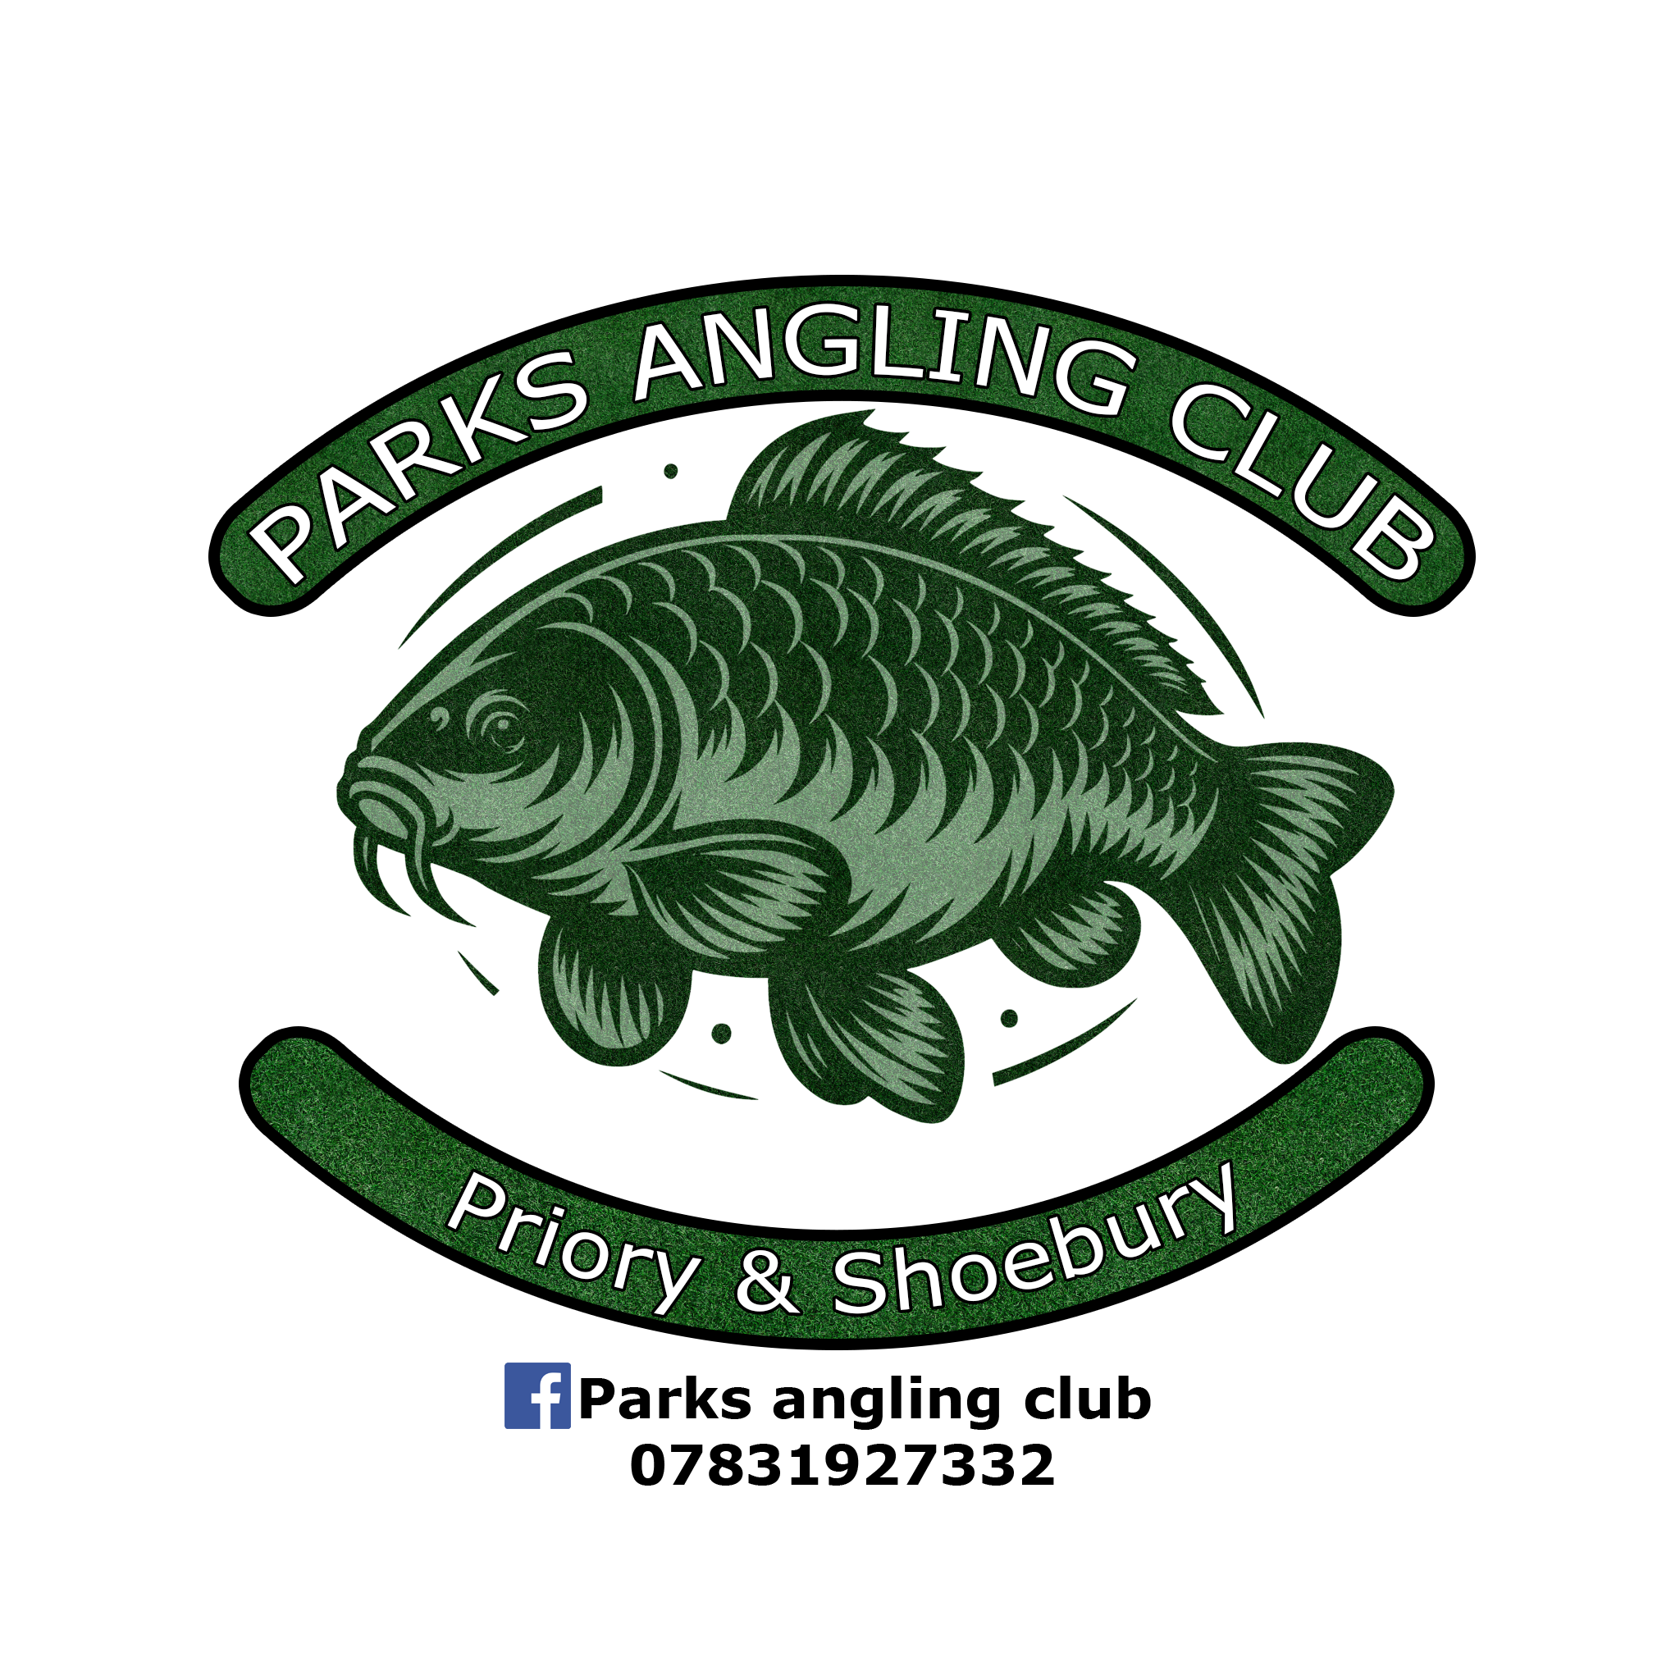
Parks Angling Club
Membership application form
Surname _______________________________________________
Forename _______________________________________________
Contact no. _______________________________________________
Age _______________________________________________
Prices March 16 – March 15
Priory Park
Senior (16 – 64) £150 ___________
Junior (under 16) £80 ___________
Concession (over 65) £80 ___________
Shoebury Park
Senior (16 – 64) £110 ___________
Junior (under 16) £60 ___________
Concession (over 65) £60 ___________
Dad ‘n’ Lad (1 Snr & 1 Jnr) £150 ___________
I declare that should my application be accepted, I will abide by the club rules, the park bylaws, and those of the Environment Agency. I also confirm I have not been dismissed or refused admission to this or any other angling club in the past.
Signed _______________________________________________
Date _______________________________________________
Fishery Manager: Matt Eade, 07831 927 332
Bailiffs: Carl Barrett, Lewis Taylor, Andy Regan, Paul Raven
Please complete this form and return to an above-named bailiff or to info@parksanglingclub.co.uk
If membership has been agreed, please ensure payment is made in full in cash or BACS to the details provided below.
PAYMENT REQUIRED IN FULL BEFORE THE START OF THE NEW SEASON.
Please complete a separate form for each individual applying.
Parks Angling Club reserve the right to refuse permission to applications without giving cause.
DO NOT MAKE PAYMENT UNTIL MEMBERSHIP HAS BEEN ACCEPTED.
BACS payment details;
Account name Parks Angling Club
Account no. 2228 3760
Sort Code 30 54 66
Please leave your surname as the reference.

